ITA0501-Computer Vision
C02-AT2-Scenario Based Questions

1. Dental X-Ray Enhancement and Cavity Region Extraction
Introduction:
Dental X-ray images are used by dentists to identify cavities and other problems in teeth. However, these images may have low brightness, poor contrast, quantum noise and overlapping tooth structures. Due to these problems, small cavities may not be clearly visible. Digital image processing techniques can improve the image quality and help extract suspected cavity regions.
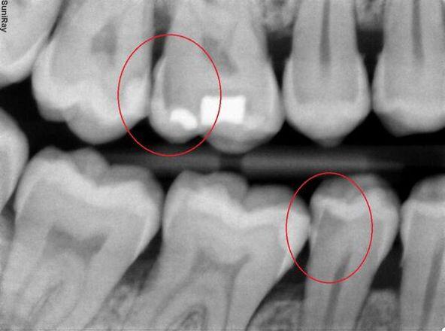

Processing Steps
Step 1: Grey-Level Transformation
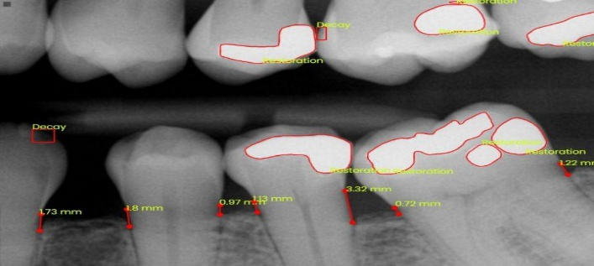
A power-law transformation is used to improve the brightness of dark regions in the dental X-ray. By selecting a gamma value less than 1, dark areas become brighter and small cavity details become more visible. A negative transformation can also be considered when reversing the intensity values makes dark cavity regions easier to distinguish from surrounding tooth structures.

Step 2: Histogram Equalization
Histogram equalization improves the contrast of the X-ray by spreading the intensity values across a wider range. Contrast Limited Adaptive Histogram Equalization (CLAHE) is particularly suitable because it enhances local contrast around small cavity regions without excessively amplifying noise. This makes the differences between enamel, dentine and suspected cavities easier to observe.
Step 3: Spatial Smoothing Filter
A median filter is applied to reduce unwanted noise while preserving important edges. A small filter window is preferred because excessive smoothing may blur the boundaries of small cavities. A bilateral filter is another suitable option because it reduces noise while preserving strong intensity differences around boundaries.
Step 4: Cavity Region Extraction
Adaptive thresholding is used to separate suspicious dark regions from the surrounding tooth structures. It is useful when brightness varies across the image. Alternatively, region growing can be applied by selecting a seed point inside a suspected cavity and adding neighbouring pixels with similar intensity values. This produces a candidate cavity region.
Step 5: Edge Detection and Boundary Extraction
The Canny edge detection method is applied to identify strong intensity changes around the extracted region. Boundary tracing then connects the detected edges to outline the suspected cavity. Small isolated regions caused by noise can be removed using suitable area-based filtering.
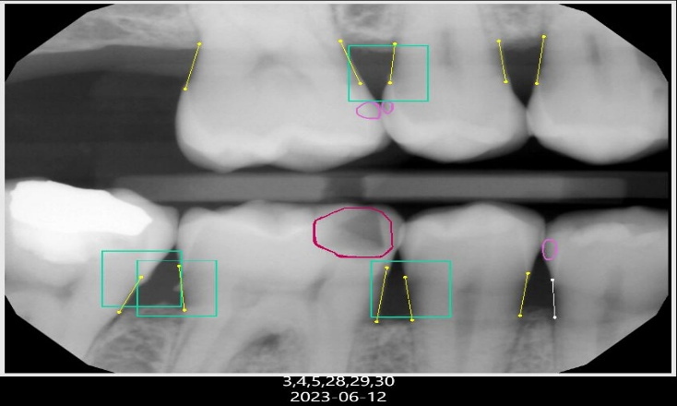

Justification of Techniques:
Power-law transformation improves dark-region visibility, while CLAHE enhances local contrast. Median filtering reduces noise without unnecessarily damaging cavity boundaries. Adaptive thresholding and region growing help separate suspicious areas, and Canny edge detection provides a clear outline of the extracted region.
Result and Conclusion:
The proposed processing sequence improves the visibility of dental X-ray images and identifies candidate cavity regions. These results can help dentists inspect suspicious areas more easily. However, image processing alone cannot confirm the presence of a cavity; the final interpretation must be made by a qualified dentist.
2. Night-Time Vehicle Number Plate Region Extraction
Introduction:
Traffic police departments use CCTV cameras at toll gates to capture vehicle number plates. During nighttime, images often suffer from low brightness, headlight glare, sensor noise and motion blur. These problems make the number-plate characters difficult to read. Digital image processing techniques can enhance the image and extract the rectangular number-plate region for further character recognition.


Processing Steps:
Step 1: Grey-Level Transformation

Gamma correction with a gamma value less than 1 is used to brighten dark regions of the image. This improves the visibility of the vehicle body and number plate. However, headlight glare may already be saturated, so excessive brightness enhancement should be avoided. A negative transformation may be tested, but gamma correction is generally more suitable for improving visibility in dark nighttime scenes.

Step 2: Histogram Processing
Contrast Limited Adaptive Histogram Equalization (CLAHE) improves the local contrast between the plate background and the characters. Unlike ordinary global histogram equalization, CLAHE works on small image regions and limits excessive contrast enhancement. Bright glare regions should be controlled separately where possible so that they are not mistaken for plate boundaries.
Step 3: Noise Reduction and Sharpening
A median filter is applied first to reduce isolated sensor noise. The filter size should be small to preserve thin character strokes. After noise removal, mild unsharp masking or Laplacian sharpening can be used to strengthen the edges of the characters. Sharpening is performed after smoothing because it may amplify noise if applied directly to the original image.
Step 4: Edge and Line Detection
The Canny edge detection method identifies strong edges in the enhanced image. Horizontal and vertical line detection is then used to locate possible rectangular number-plate boundaries. Edge linking connects nearby edge segments to form a more complete rectangle, even when some parts of the plate boundary are weak or interrupted.
Step 5: Number Plate Extraction
Rectangular candidates are examined based on their aspect ratio, size and edge arrangement. The most suitable candidate is selected and cropped from the original or enhanced image. Adaptive thresholding is then applied to separate dark characters from the plate background. The extracted plate can subsequently be passed to an optical character recognition system.

Justification of Techniques:
Gamma correction improves dark-region visibility, while CLAHE enhances local contrast. Median filtering reduces noise before sharpening strengthens character edges. Canny detection, line detection and edge linking help locate the rectangular plate boundary. Adaptive thresholding is suitable for separating characters when illumination is uneven.
Result and Conclusion:
The processing pipeline produces an enhanced image and an extracted number-plate region with improved character visibility. This helps prepare the image for automatic number-plate recognition. Severe motion blur may still reduce accuracy, so selecting a clearer frame is important whenever multiple video frames are available.

3. Textile Fabric Defect Detection Using Frequency-Domain Processing
Introduction:
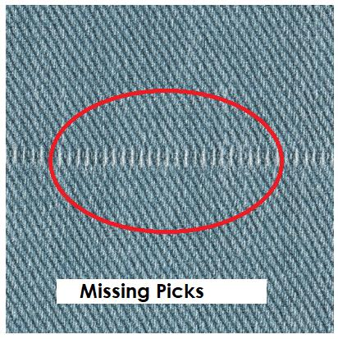
Textile industries use digital cameras to inspect woven fabric and identify defects such as holes, broken threads, oil stains and knots. Fabric contains a regular repeating weave pattern, which may hide small defects. Periodic lighting noise and uneven illumination can also affect image quality. Frequency-domain processing is useful because repeating patterns and periodic noise often produce identifiable frequency components.

Processing Steps:
Step 1: Illumination Correction
The original fabric image may contain bright and dark areas because of uneven lighting. Background estimation and illumination normalization are applied to reduce these variations. Histogram stretching or CLAHE can then improve the contrast between normal fabric and defective regions.
Step 2: Fourier Transform
The two-dimensional Fast Fourier Transform (FFT) converts the image from the spatial domain into the frequency domain. In this representation, the repeating weave pattern and periodic lighting noise may appear as concentrated peaks or repeated frequency structures. Examining the frequency spectrum helps identify unwanted components.

Step 3: Frequency-Domain Filtering
Notch filtering is used to suppress specific frequency peaks caused by periodic noise. Band-reject filtering can remove an unwanted range of frequencies when the noise occupies a known band. A low-pass filter reduces high-frequency variations, while a high-pass filter can emphasize fine details such as broken threads. However, these filters must be selected carefully because genuine defects may also contain high- or low-frequency information.
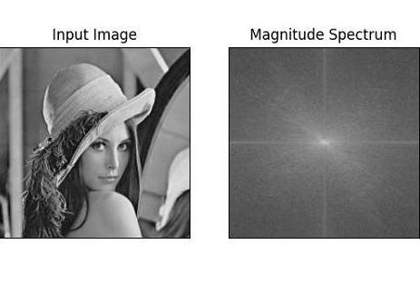
Step 4: Inverse Fourier Transform
After filtering, the inverse Fourier Transform converts the processed image back into the spatial domain. The resulting image should contain reduced periodic interference while retaining important defect details. The filtered image is compared with the original to ensure that small holes and broken threads have not been removed.
Step 5: Thresholding and Boundary Detection
Thresholding is applied to the processed image or to an anomaly image representing differences from normal fabric texture. Pixels that differ significantly from the expected texture are marked as possible defects. Connected-component analysis groups neighbouring pixels, and boundary detection outlines each defective region. Small false detections can be removed using area and shape criteria.

Justification of Techniques:
Frequency-domain filtering is preferred because periodic noise and regular weave patterns can often be identified by their frequency components. A spatial smoothing filter acts locally and may blur the defects together with the unwanted texture. Notch and band-reject filters allow selected periodic components to be suppressed while preserving other image information.
Result and Conclusion:
The proposed pipeline reduces periodic noise and unwanted weave patterns, improving the visibility of textile defects. Thresholding and boundary detection then identify and outline holes, broken threads, stains and knots. Proper filter selection is essential because excessive filtering may remove genuine defect details.
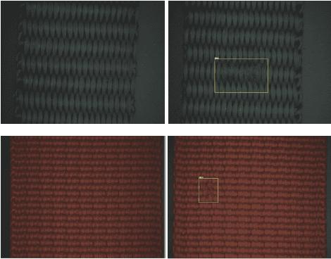

4. Blood Cell Segmentation in Microscopic Images
Introduction:
Pathology laboratories use microscopic images of stained blood smears to count red blood cells and white blood cells. These images may contain uneven staining, poor contrast, dust particles and overlapping cells. When cells touch each other, a simple thresholding method may identify them as one large region. Image enhancement, filtering and region-based segmentation are therefore required to identify individual cells accurately.
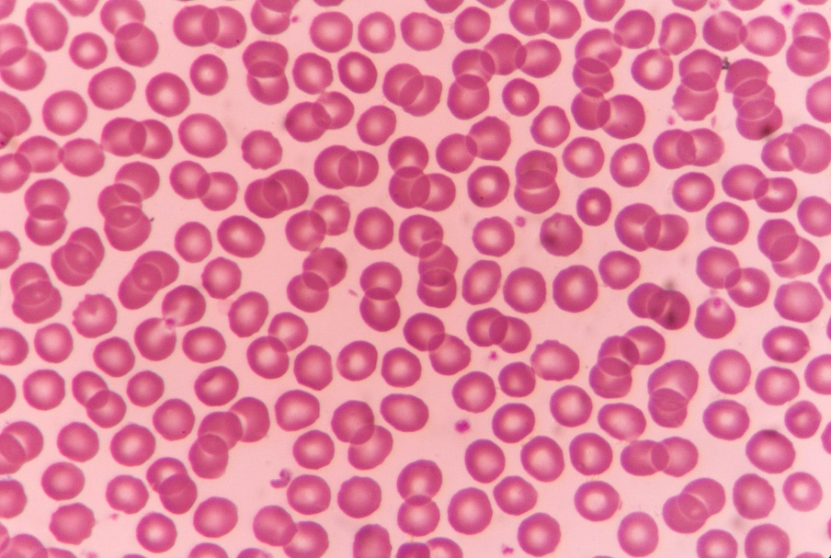

Processing Steps:
Step 1: Contrast Enhancement
Contrast enhancement is applied to improve the difference between blood cells and the surrounding background. CLAHE is a suitable method because it improves local contrast and helps reveal cell boundaries even when staining varies across the image. Background illumination correction may also be performed to reduce broad brightness variations.
Step 2: Spatial Noise Filtering
A median filter is used to remove small dust particles and isolated noise. The filter window should be kept small because excessive smoothing can destroy thin cell boundaries or merge nearby cells. A bilateral filter may also be used when preserving cell edges is especially important.

Step 3: Thresholding
Thresholding separates the cells from the background according to pixel intensity. Global thresholding is suitable when the image has nearly uniform illumination. Adaptive thresholding is more appropriate when staining and brightness vary across the image because it calculates thresholds from local neighbourhoods. The resulting binary image represents the initial cell regions.
Step 4: Region-Based Segmentation
Connected-component analysis identifies separate groups of foreground pixels. Region growing can group neighbouring pixels with similar intensity or colour. However, touching cells may still form a single connected component. To separate them, a distance transform and watershed segmentation can be applied. The distance transform identifies cell centres, and watershed divides merged regions into individual cell regions.
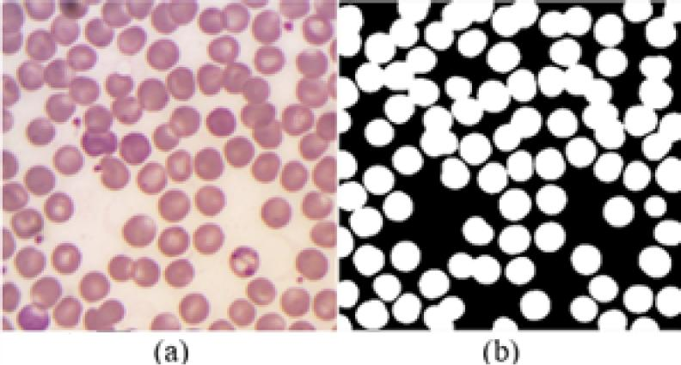

Step 5: Edge and Boundary Detection
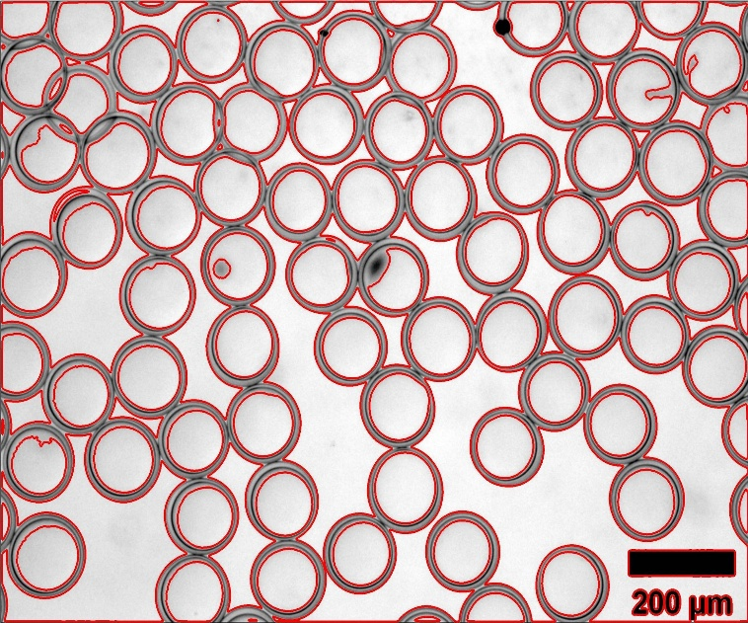
Canny edge detection identifies intensity changes around cell boundaries. Boundary tracing then outlines individual cells. Area, shape and intensity measurements can help reject small dust particles and other false detections. The resulting regions can be counted and analysed.

Justification of Techniques:
CLAHE improves cell visibility under uneven staining conditions. Median filtering removes noise while preserving important cell details. Adaptive thresholding separates cells from a changing background, and region growing groups similar pixels. Watershed segmentation is particularly useful for separating touching cells. Edge detection and boundary tracing provide outlines for individual-cell analysis.
Result and Conclusion:
The proposed processing sequence produces segmented blood-cell regions and outlines individual cells for automated counting. It improves the separation of cells from the background and helps distinguish touching cells. The parameters must be validated on representative microscopic images to avoid missing small cells or incorrectly splitting individual cells.

5. Text Extraction from Degraded Historical Documents
Introduction:
Historical documents stored in archives may contain faded handwriting, yellowed paper, stains, ink bleed-through and uneven illumination. These problems reduce the contrast between ink and paper, making automatic handwriting recognition difficult. Digital image processing can improve the visibility of faded strokes and extract text lines and word regions before recognition.
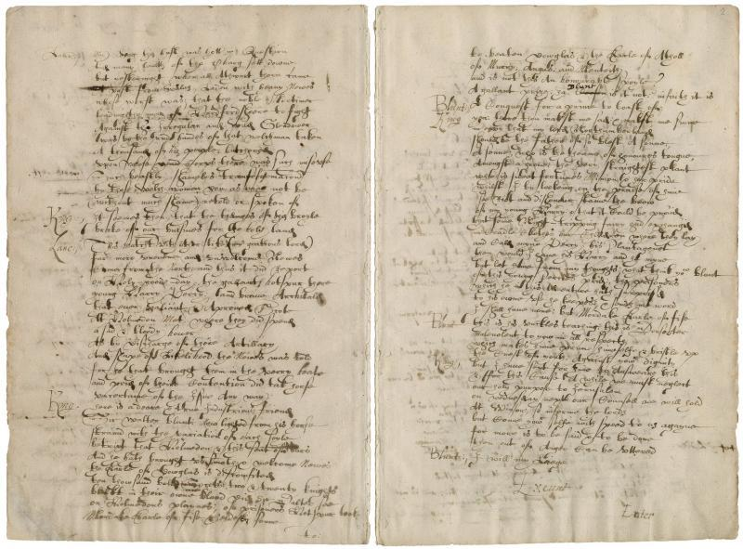
Processing Steps:
Step 1: Grey-Level Transformation
The scanned document is converted into a grayscale image to simplify intensity-based processing. Gamma correction or logarithmic transformation can be used to improve the visibility of faint pen strokes. The transformation should be selected carefully because excessive enhancement may also make stains and reverse-side ink more visible.


Step 2: Histogram Processing
Histogram equalization improves the contrast between the handwriting and the paper. CLAHE is often more suitable because the document may contain local differences in brightness and paper colour. Background normalization can further reduce uneven illumination across the page and make the ink strokes more consistent.
Step 3: Smoothing and Sharpening
A gentle median filter removes small isolated spots and noise. Strong smoothing should be avoided because it can erase thin or faded handwriting. After noise reduction, mild unsharp masking can strengthen pen strokes and improve their visibility. If bleed-through is strong, additional background or bleed-through suppression may be required.
Step 4: Global and Adaptive Thresholding
Otsu's method is a global thresholding technique that automatically selects one threshold for the entire image. It works well when the paper background and ink have reasonably distinct intensity distributions. However, historical pages often have uneven lighting, stains and yellowing, so a single threshold may fail in some regions.
Adaptive thresholding calculates a separate threshold for each local neighbourhood. It is generally more suitable for degraded historical documents because it can handle local variations in brightness. Therefore, adaptive thresholding is selected as the main method for separating the text from the background, while Otsu's method can be used as a comparison.

Step 5: Text-Line and Word Extraction
After thresholding, small morphological operations may remove isolated specks or connect broken strokes. These operations must be used carefully so that nearby words are not merged. Connected-component analysis identifies individual text components, while horizontal projection can help group characters into text lines. Boundary detection is then used to outline text-line and word regions.
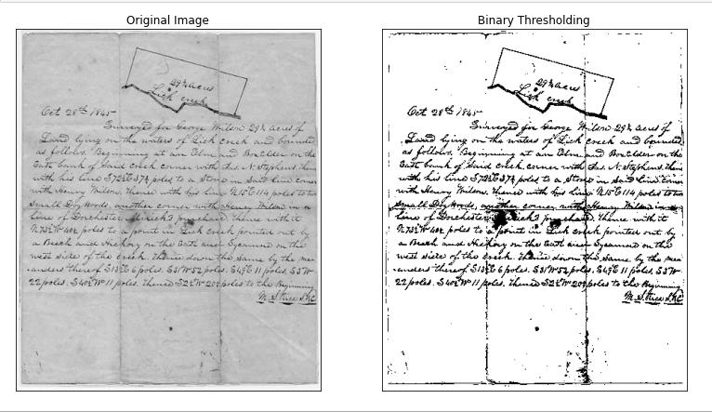
Justification of Techniques:
Grey-level transformations and CLAHE improve the visibility of faded ink. Gentle smoothing removes noise without destroying important handwriting details, while sharpening strengthens the strokes. Adaptive thresholding is preferred over global Otsu thresholding because the paper background and illumination vary across the page. Connected-component analysis and boundary detection help locate text regions for further recognition.
Result and Conclusion:
The processing pipeline produces an enhanced document image with improved ink visibility and separated text regions. Adaptive thresholding provides better separation under uneven illumination, while text-line and word extraction prepares the document for handwriting recognition. Careful parameter selection is necessary to preserve faded strokes and avoid treating stains or bleed-through as actual text.

